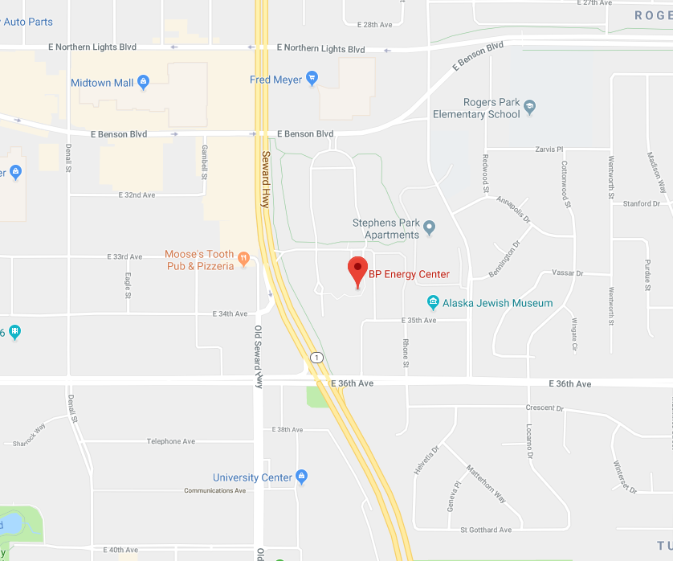

**Parking  
1014 Energy Court**